**Project 3h – Dialing your favorite color**

Task: Generate your favorite color using three pots, sampled with ADCs, controlling 3 PWMs, to drive an RGB LED using Arduino commands.

Procedure: The project contains the following steps:

* Test RGB LED
* Build diffuser
* Digital pins for 5V & GND for Pots
* Convert 10-bit ADC to 8-bit PWM
* Display RGB PWM values

**Circuit diagrams -** Sketch circuit showing connections of RGB LED and pots to UNO pins, labeled with pin# and pin function (IN, OUT, ADC, PWM, …), 5V, and GRD.

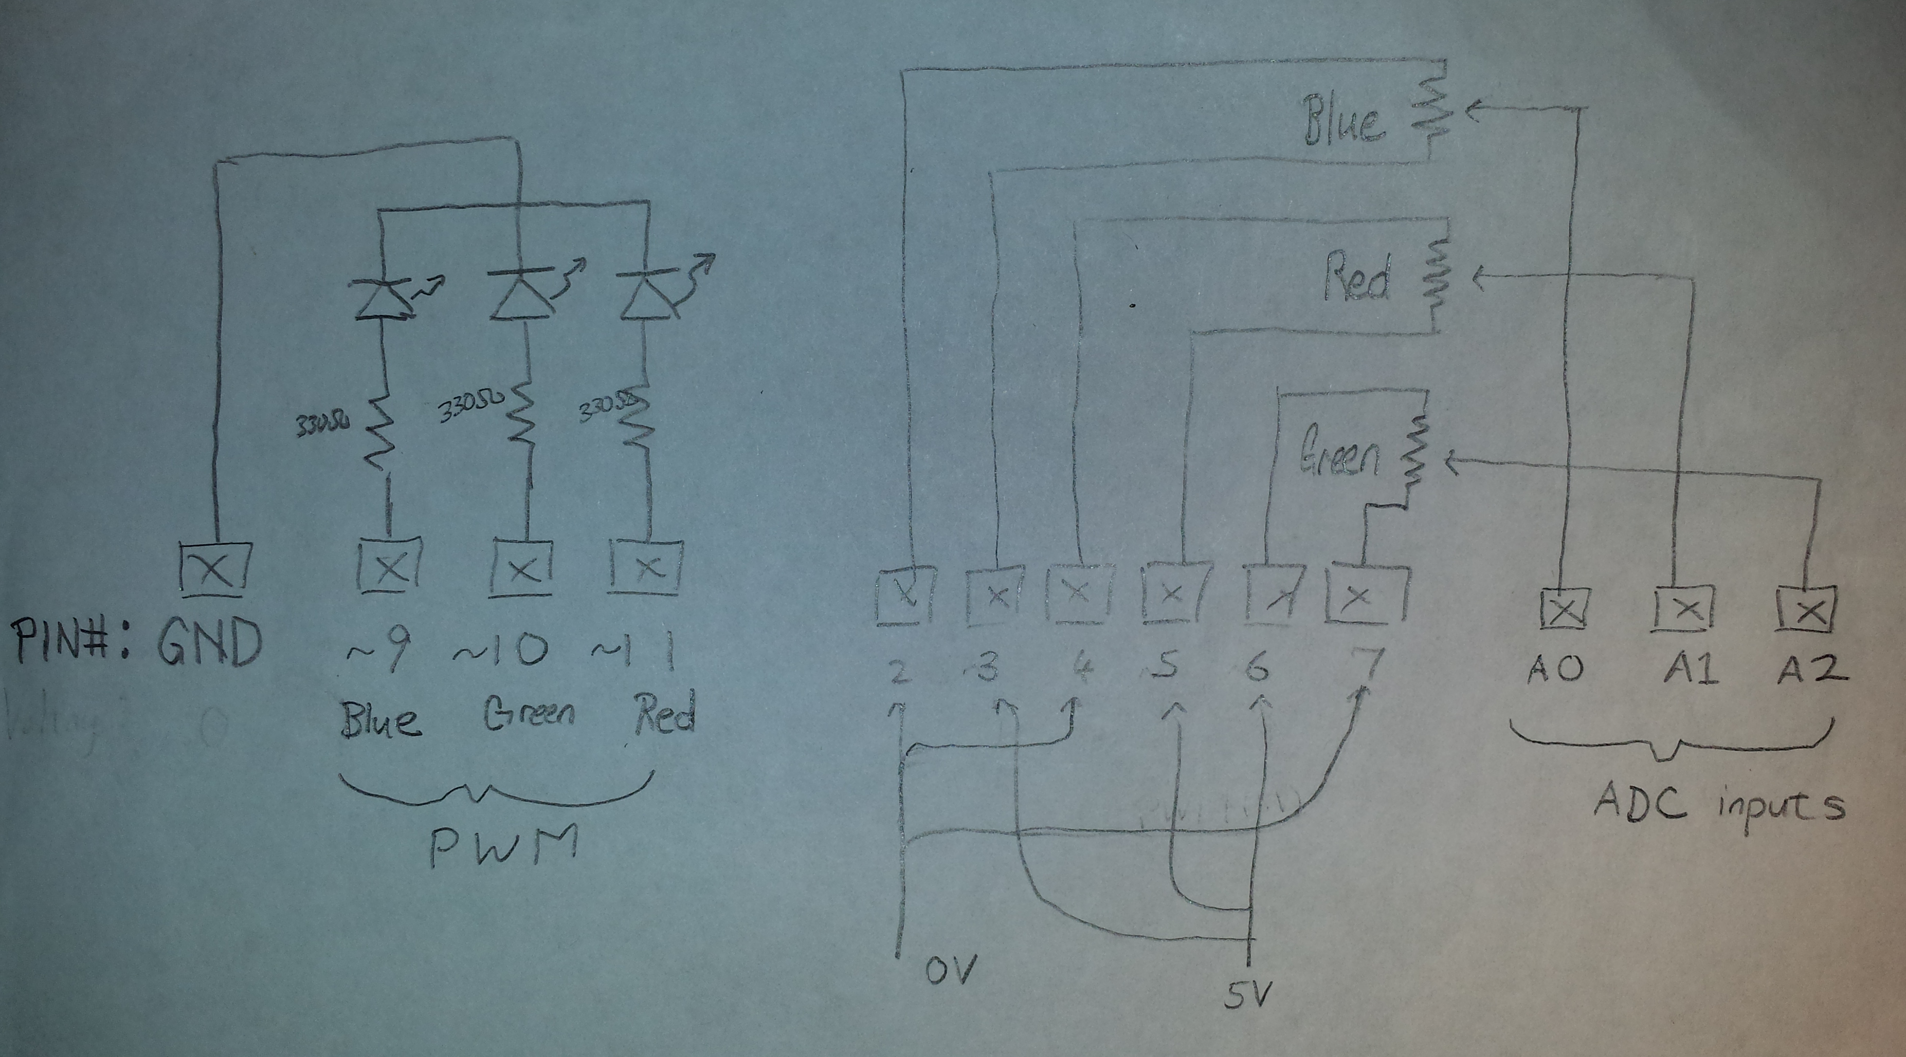

***Left: LED Circuit*; Right: Potentiometers Circuit***

\****Pin 9 voltage determined by A0***

***Pin 10 voltage determined by A2***

***Pin 11 voltage determined by A1***

**Programs –**

**P03h – Hobbyist Commands**

**Questions**:

1. For your favorite color, other than black, white, and pure red, green, and blue:

Electric Lime (RGB: 204, 255, 0)

* 1. What is the ADC value for RGB LEDs?

Red ADC val: 816

Green ADC val: 1020

Blue ADC val: 0

* 1. What is corresponding average PWM voltage?

Red: (((204/255)*2)/2) = 4V

Green: 5V

Blue: 0V

* 1. Compute the average current through each LED with 330Ω and 5V supply with VLED=2V.

Red: 4/330 = 12mA

Green: 5/330 = 15mA

Blue: 0A

Project due Monday 8am. Upload to drop box first_last_03.docx and first_last_03.ino files